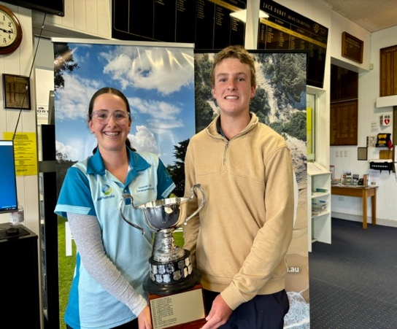
G.E.G MIXED FOURSOMES CHAMPIONSHIPS

Current Title Holders: Maddison Kelly & Cooper Rimington

To be held at

South Pines Golf Club

Sunday 22rd November 2026

$30.00 per pair ~ 10.30 timesheet start

preferred payment option Direct Debit ~ BSB 633000 179018338 ref: M4’s + surname
CASH ONLY payment will be accepted on the day.

Food will be available on the day. Price & content as determined by South Pines..

G.E.G MIXED FOURSOMES CHAMPIONSHIP Scratch
Foursomes Scratch Runner up’s
Foursomes Nett
Foursomes Nett Runner up’s
A & B Grades all events
if numbers permit
NTP: 2nd Men & 13th Women + DTL balls
Men Hit off Even numbered holes & Women odd numbered holes
Daily handicap limits: Women 45.4

CONDITION OF ENTRY
1: The competition shall be played in accordance with the Rules of Golf as adopted by the Royal and Ancients Club of St. Andrews, together with such local rules as are in force on the course on which the competition takes place. The event will be played under the auspices of all current Golf Australia policies.
2: All tied Scratch events shall be decided by a playoff and Handicap events shall be by countback.
3: Any GEG Affiliated Club Member who holds a G.A. handicap is eligible to play in the event. Players may partner a player from another Club but should a player partner a player who resides outside the GEG District & is not an eligible member of a GEG Club they will be ineligible to win any event or prize associated with the event.~ an eligible player is one who can win an honour board event at his/her Club
ENTRIES TO BE SENT TO C. Munday ~ Tournament Sec ~ cmunday7@bigpond.com

Christine Munday
17 Bakker Pl.
MAFFRA 3860
Email: cmunday7@bigpond.com 0448 447 870

ENTRY FORM
MIXED FOURSOMES’ CHAMPIONSHIPS

Player 1:

Home Club: Golf Link Nos:

Player 2:

Home Club: Golf Link Nos:

Email for Draw or Phone nos:

ENTRIES TO CLOSE FRIDAY 13TH NOVEMBER 2026 @ 5.00pm

